Arab country price dash board
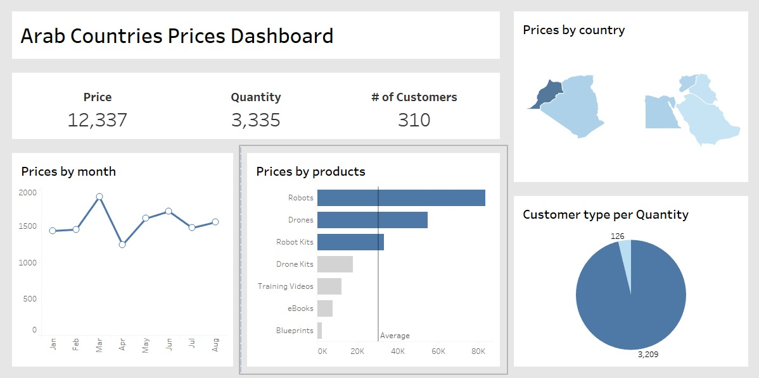

Price by month :
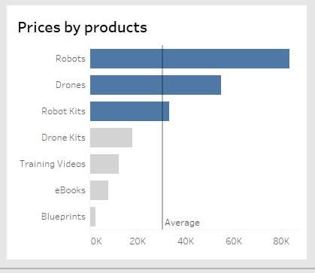
This chart show the prouduts by the prices:
I use this chart because this chart show xaxis and y axis
I showed the product in the yaxis and salary in xaxis
And I show the averg in it
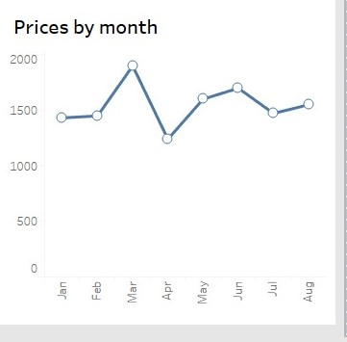
Price by month :
I use line chart because It shows a decrease and increase in value across different months
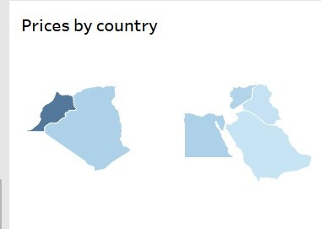
Price by country :
I use map chart because I is show the country in the map and show The price level is shown according to the color level
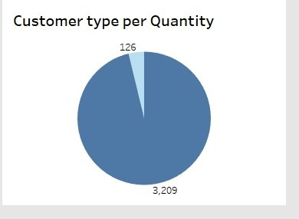
Coustomer type per quantity:
Details:
Bar charts provide clear comparisons between customer types, aiding segmentation analysis.Shows the number of customers in each customer type category.

